Figure 1- Activity Diagram- User Registration

Figure 2-Activity Diagram- User Login

Figure 3- Activity Diagram- Posting a travel experience

Figure 4- Booking a service

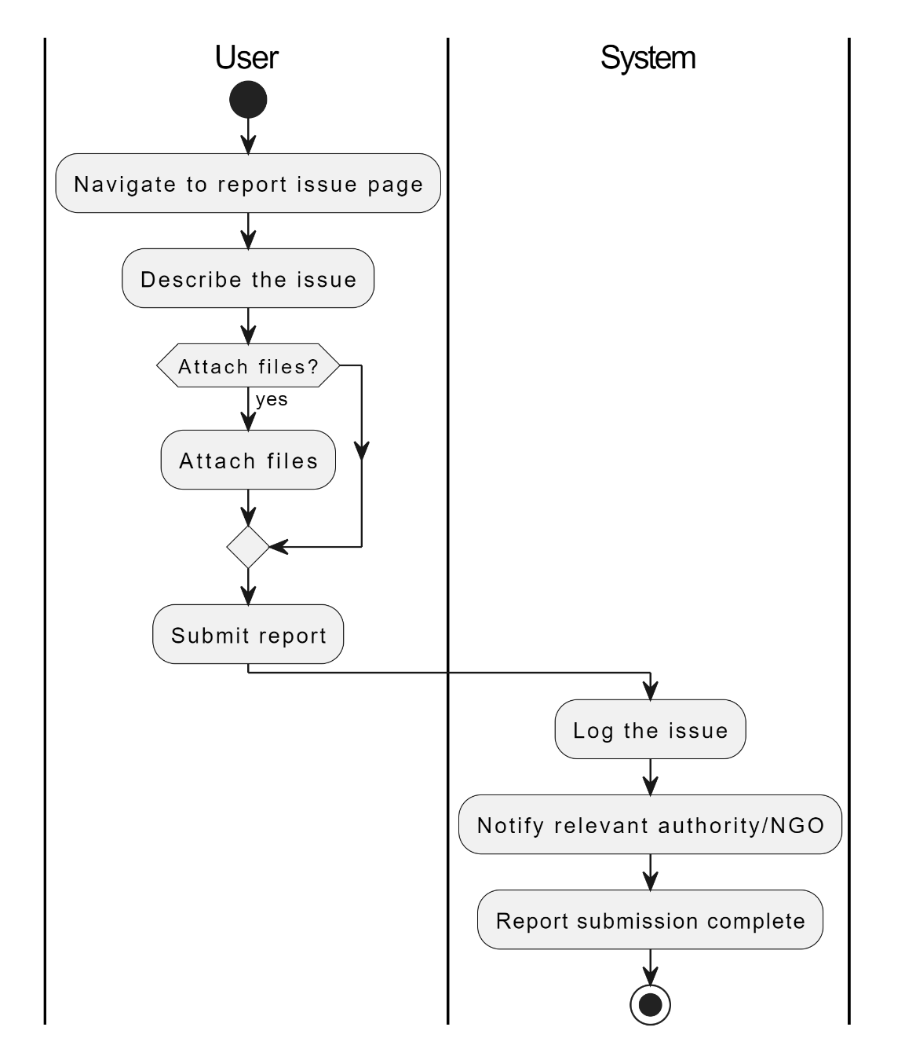

Figure 5- Activity Diagram- Reporting an issue

Figure 6- Activity Diagram- Create a Forum topic